Objective
The objective of this assignment is to deploy a Flask backend and an Express frontend using different AWS deployment strategies.
The assignment consists of the following tasks:
- Deploy Flask backend and Express frontend on a single Amazon EC2 instance.
- Deploy Flask backend and Express frontend on separate Amazon EC2 instances.
- Deploy Dockerized Flask backend and Express frontend using Amazon ECR, Amazon ECS, and Amazon VPC.
Task 1: Deploy Flask Backend and Express Frontend on a Single EC2 Instance

Architecture
Internet
↓
Amazon EC2
── Flask Backend (Port 5000)
── Express Frontend (Port 3000)
Steps Performed
- Launched Ec2 Instance
- Configured inbound rules
  - SSH 22 – My IPV4
  - Custom TCP – 3000
  - Custom TCP – 5000
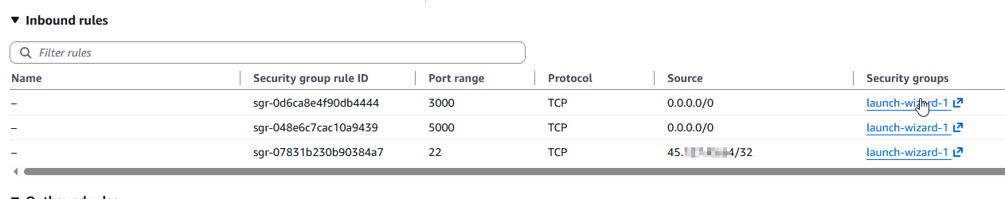
SSH and login to the server
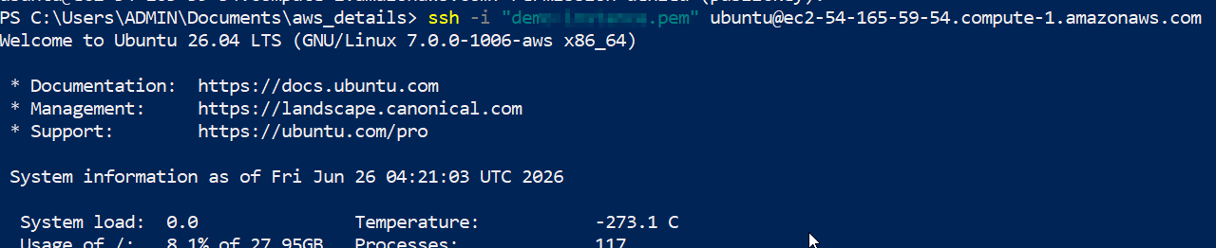

Installed required packages
- sudo apt update && sudo apt upgrade -y
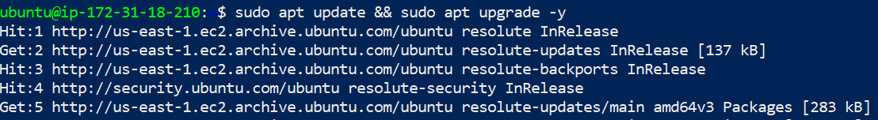
- Installed git
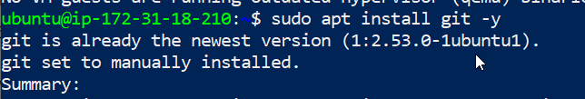
- Installed python3 and pip3
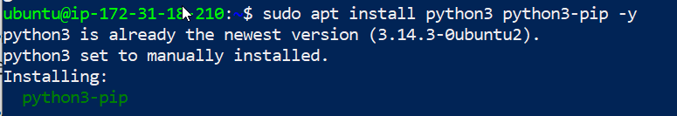
- Downloaded node setup
- Installed nodejs
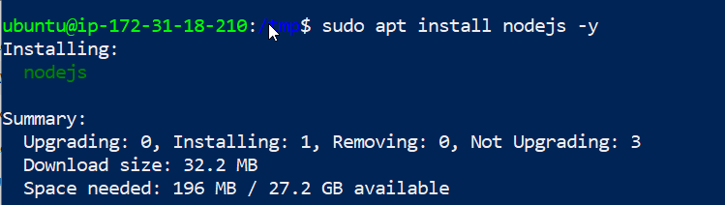
- Clone Project
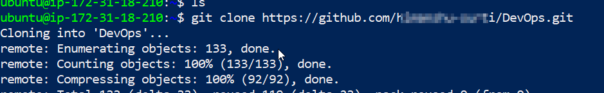
- Installed python environment
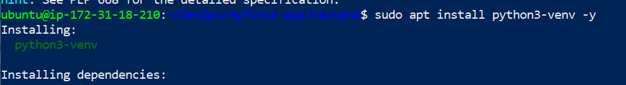
- Activate environment and installed backend dependencies
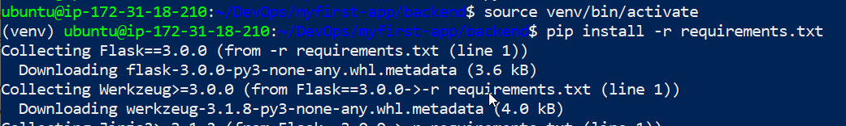
- Run the backend project
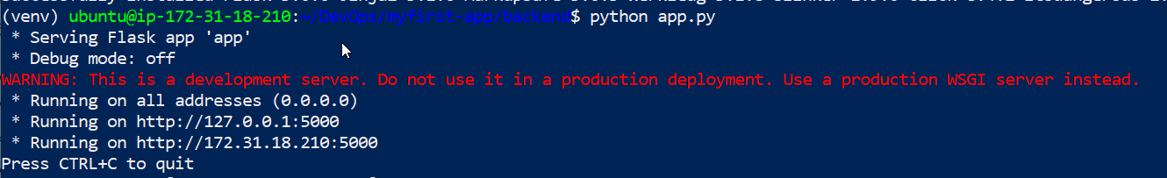
- Setup frontend
Went to frontend folder and install dependencies through npm install
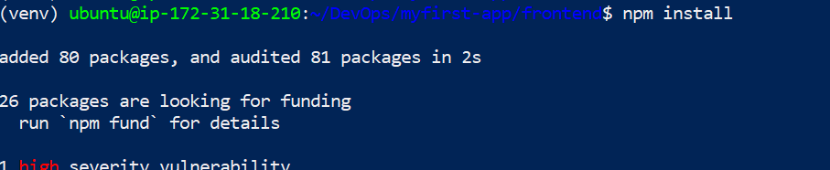
- Run the project node server.js
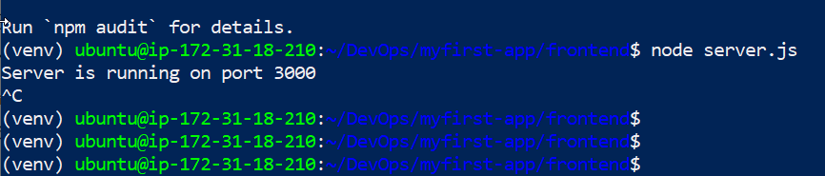
- Services running
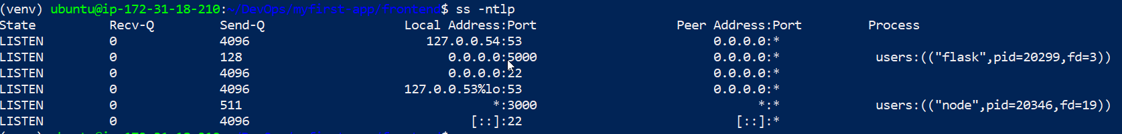

TASK 2
Frontend Server Setup
- Update the server
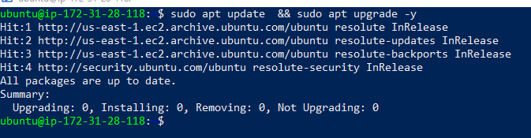
  - Sudo apt update
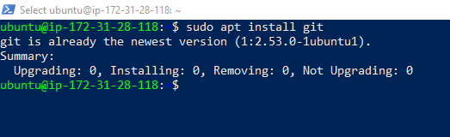
  - Installation of git as I have already installed its showing git is already the newest version
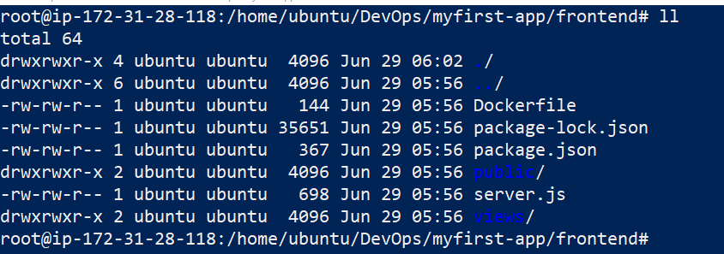
  - Clone the repositories
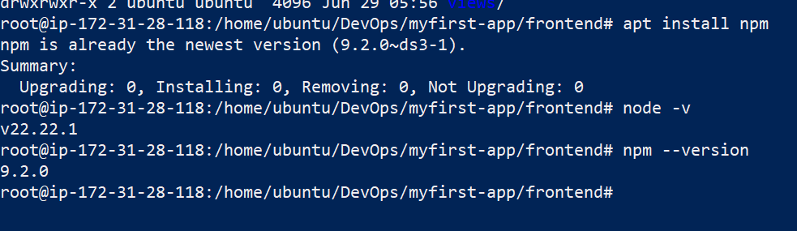
  - Installed node and npm

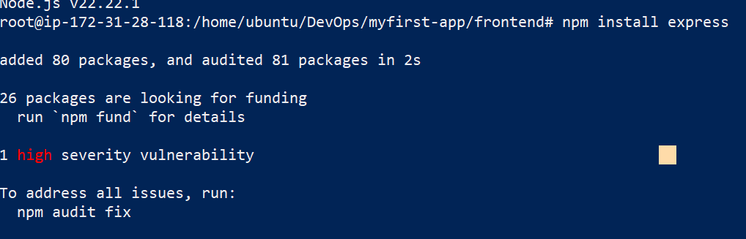
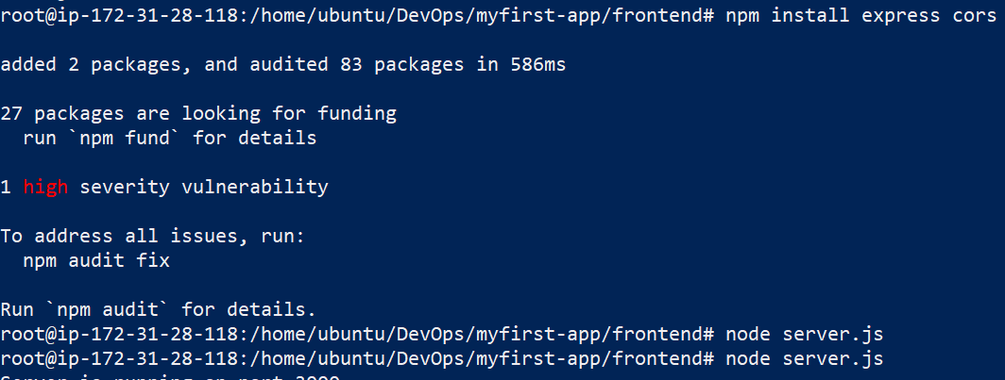
  - Found few challenges where express and cors were not install hence I have installed the same via npm install cors express
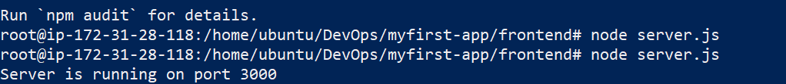
  - Now run the project with node server.js
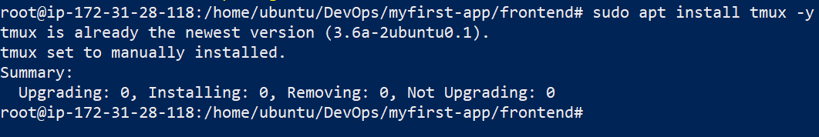
  - To keep the sever frontend running I have installed tmux
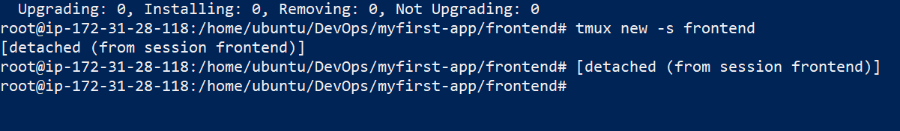
  - Run the server
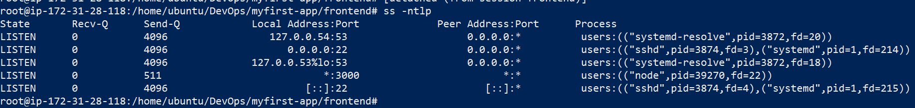
  - Ctrl + b and then d
  - Port 3000 is running

TASK 3
Similarly to task 2
- I have update and upraded the server and git was already installed
- I cloned the repository and went to backend folder
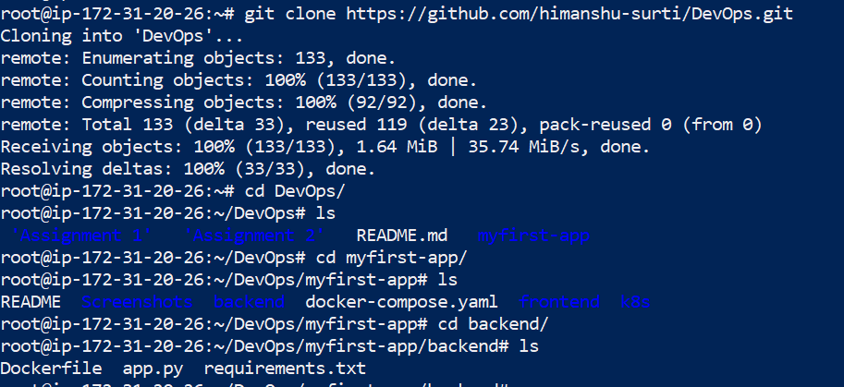
Installing required dependencies
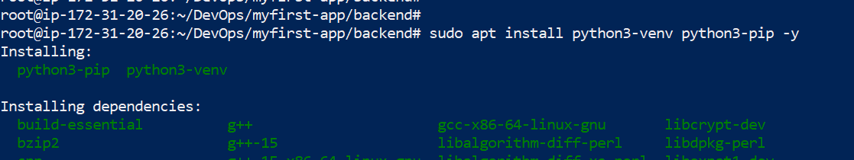
Create a virtual environment
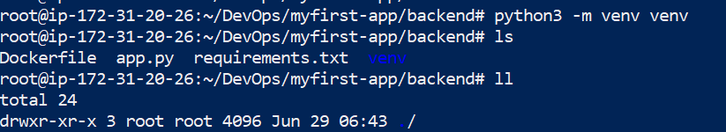
Activate and install required dependencies
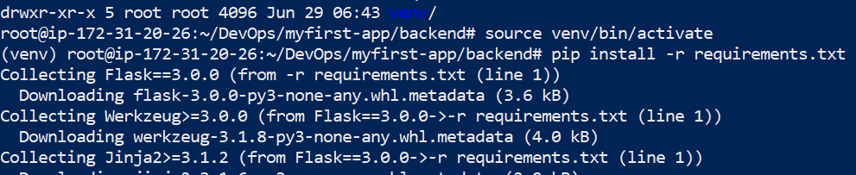
Run the backend application

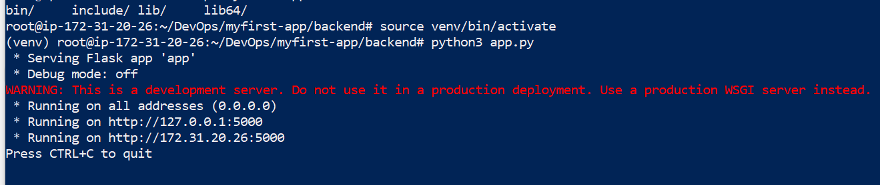
$ python3 app.py
Task 1 URL:
Frontend Url: http://54.165.59.54:3000/
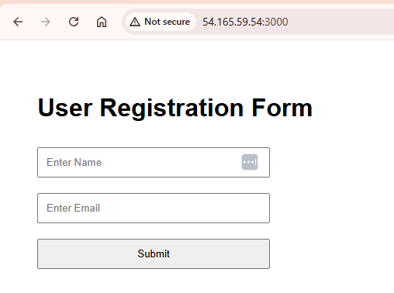
Task 2 Urls
Frontend: http://34.232.126.85:3000/
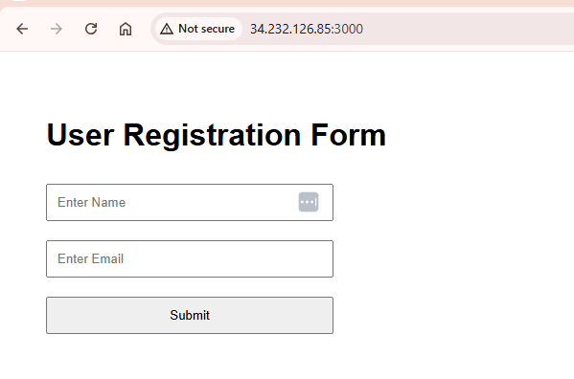

Backend: http://32.193.133.71:5000/
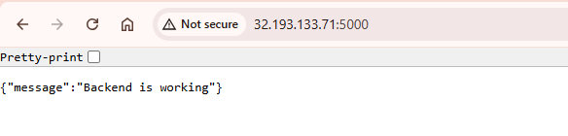

TASK 3
Deployed frontend and backend on ECS
Backend Url: http://100.24.58.12:5000/

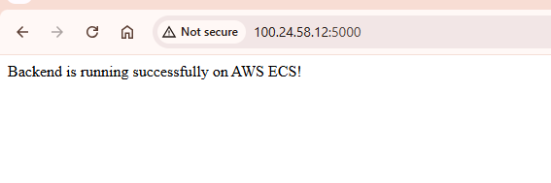

Frontend url
http://98.80.100.164:3000/

